Operating System ProjectVoice-Controlled Operating System

short line

Ali Aman (18K-1091)

Mahad Sheikh (18K-0345)

Shamsa Shakir (18K-1094)   
18 June, 2020

# 

# Introduction

V.O.S. by S.A.M. is a digital voice assistant built for computing devices. It saves you the hassle of remembering commands and typing long strings, by letting you control your system by merely speaking the commands into your microphone, or using text by selecting one of the options from the auto-fill drop down menu.

Aside from that, it has many other services which let you make to-do lists, set alarms, stream your favorite Youtube videos, handle your e-mail and it also provides real-time information on weather, news, world-clock and much much more!

The assistant can be activated by first saying a trigger word (either "Jarvis" by default or any other name set by you), followed by your query ')

The aim is to ease the use of the system, even for those people who may not be familiar with programming at all.

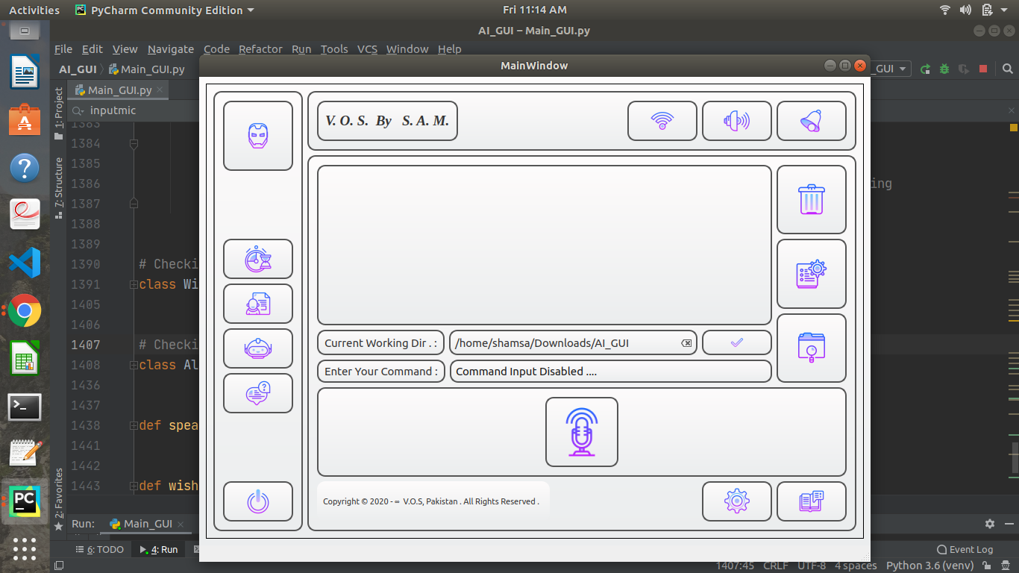

# Voice-controlled Operating System (V.O.S.)

## 

## IMPLEMENTATION

The project is implemented using Python and PyQt5 for GUI. To capture audio from the microphone, in-built python library Speech Recognition is used, and to decode the voice commands and change them into scripts, aid is taken from Google Speech-to-Text library.

User will simply have to call the assistant’s name to activate it and then speak one of the commands from the list made available to them in the User Manual. After validation of the command, it will be executed. The user can then either exit or call the assistant again to execute more speech commands.

# INPUT

## Voice/Text

Users can use their microphone or the provided text box to input their commands.

Even though the program is voice-controlled, the user has the option to toggle between text and voice input. This option is given, if for some reason, their microphone does not work or has any other issues, then they can still access the program.

# 

# SETUP

## User Profile settings

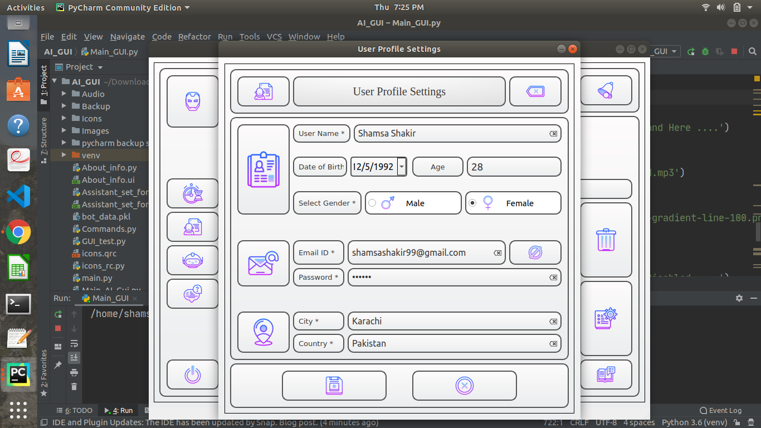

The user can set up his/her account and input personal information like Name, Gender, Date of Birth. Once the setup is done, the voice assistant will call the user Madam or Sir using this information, to make it more personal, whenever the application is accessed.

### System Settings

### 

### 

The user will set up the paths to their Image, Video and Music directories. This can be changed whenever, as per user’s wish.

### Assistant Settings

The user can set a new name for the assistant.

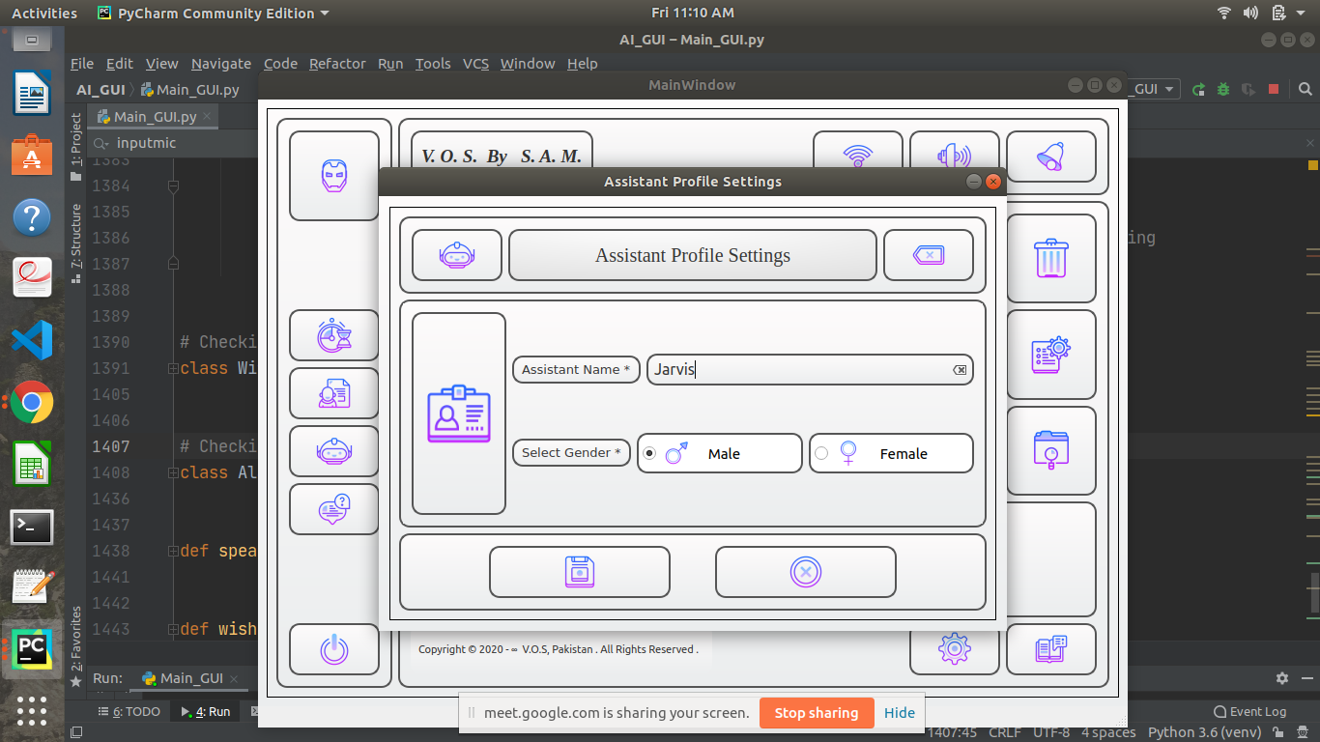

# COMMANDS MANUAL

# 

A manual is at their disposal with 78 categorized commands along with their descriptions, so the user does not have to remember all the available commands and can also see what actions they are able to carry out using the assistant.

The command categories are as follows:

* Shell Commands
* Web Commands
* System Commands

## 

## Shell Commands

These allow the user to carry out commands which are available in a typical Linux environment. Examples of these include “Create directory”, or “What is the time?” etc

* “Creates a folder”
* “Removes a Folder”
* “Shutdown”
* “List Files”
* “List Formatted Files”
* “List Hidden Files”
* “Current Working Directory”
* “What is Date Today”
* “What is the Day Today”
* “What is the Time”
* “Go to Home Directory”
* “Show network status”
* “Show running processes”
* “Display Calendar”
* “What is Username”
* “Open Text Editor”
* “Who Created You”
* “List Users”

## Web Commands

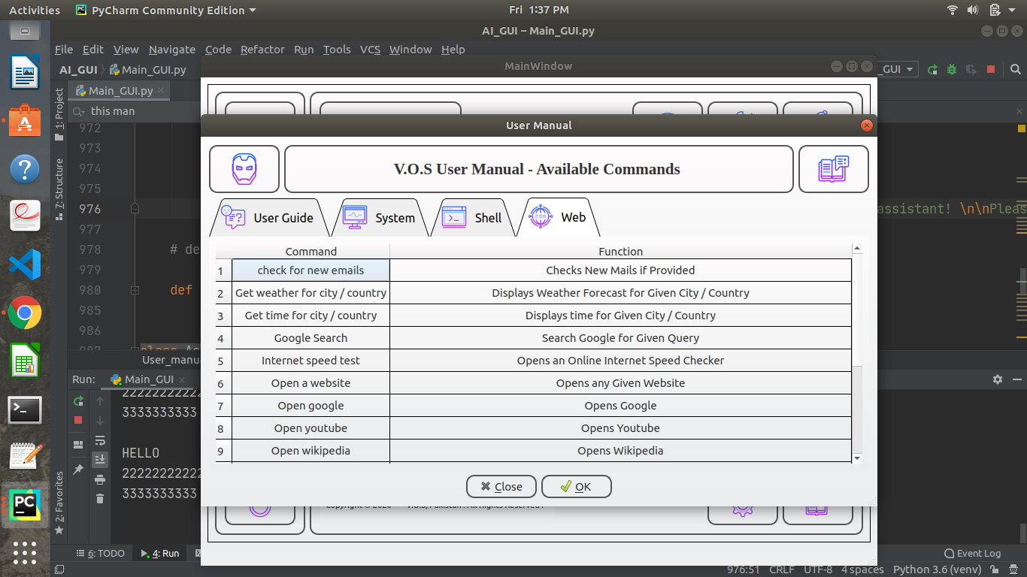

The user can carry out commands related to the Web. This allows the user to search a specific website for a specific query or search item, or send and receive emails, etc.

* “Youtube”
* “Youtube Search”
* “Wikipedia”
* “Wikipedia Search”
* “Weather Today”
* “Weather for”
* “World Clock”
* “Google”
* “Google Search”
* “Gmail”
* “Yahoo”
* “Outlook”
* “Internet Speed Test”
* “News”
* Any Website

## System Commands

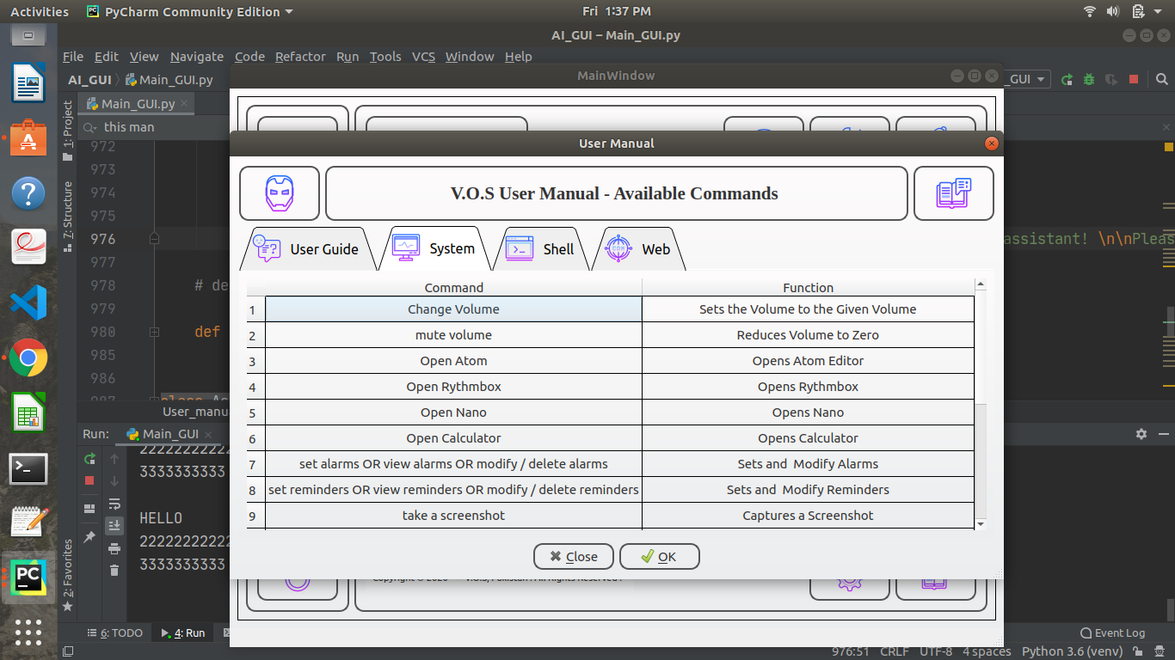

The user can control his/her system functionalities with the aid of these commands. H/she can play music, control the playlist, view slideshow as well as take screenshots and adjust music volume and screen visibility.

* “Screenshot”
* “Volume Up”
* “Volume Down”
* “Mute”
* “Zoom In”
* “Zoom Out”
* “Zoom Reset”
* “Play Music”
* “Slideshow”

# 

# HISTORY

The commands that were requested by the user, regardless of being successfully executed or not, and the corresponding assistant’s reply with time and date stamp is saved in History Tab. This can be accessed by the user whenever they please.

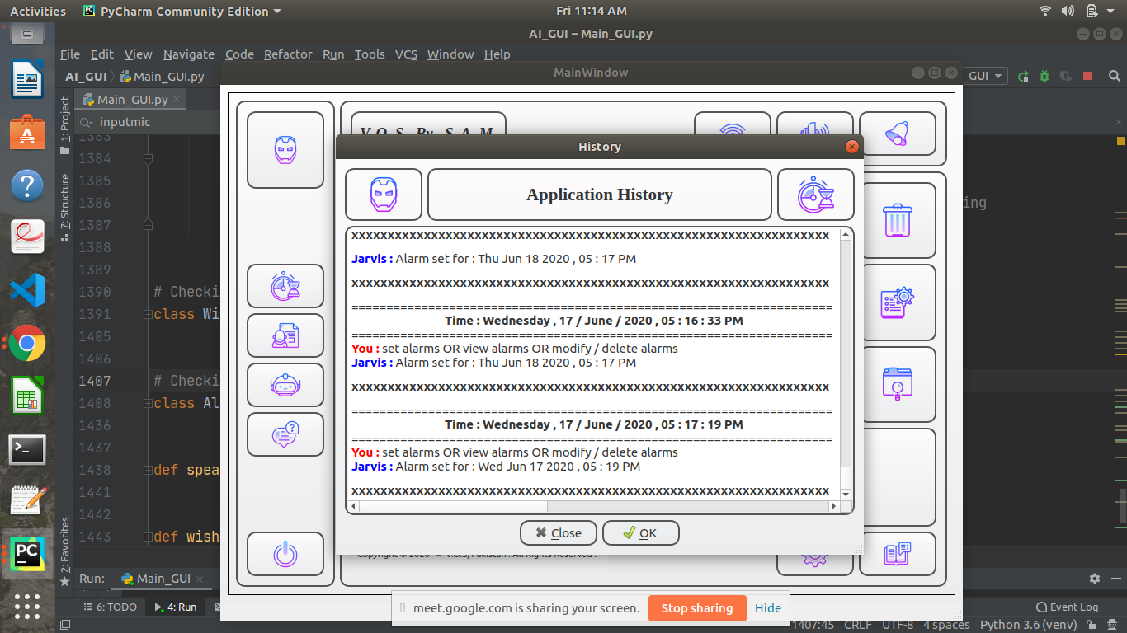

# Other Features

# Clear chatbox

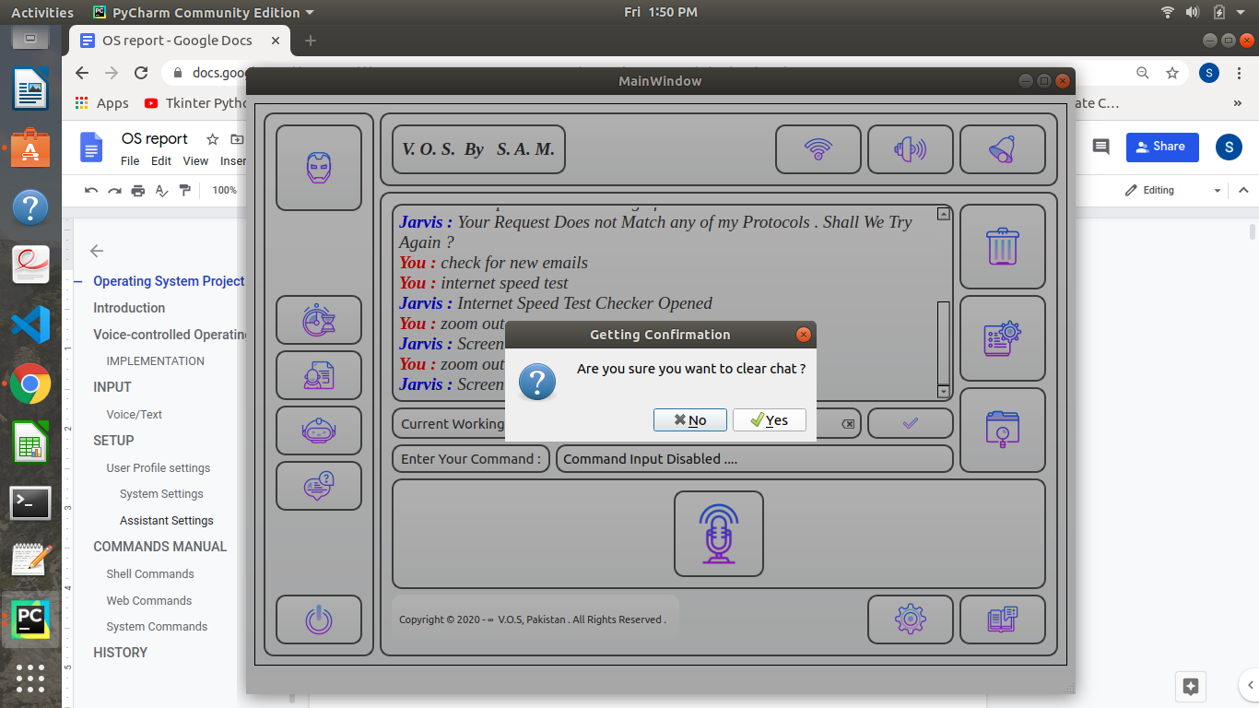

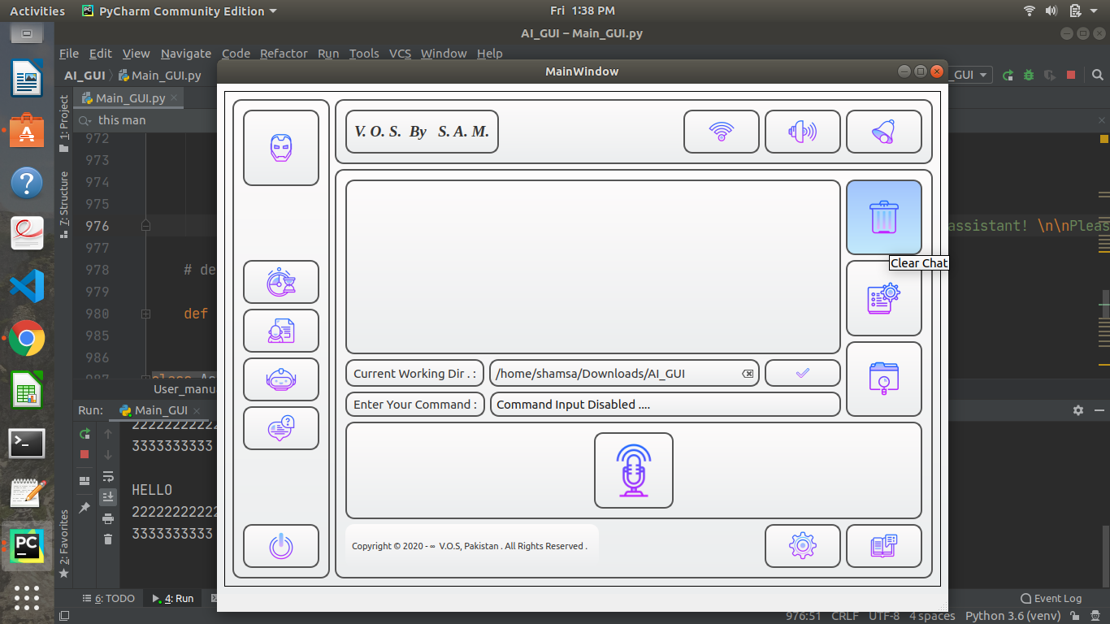

# Change Font

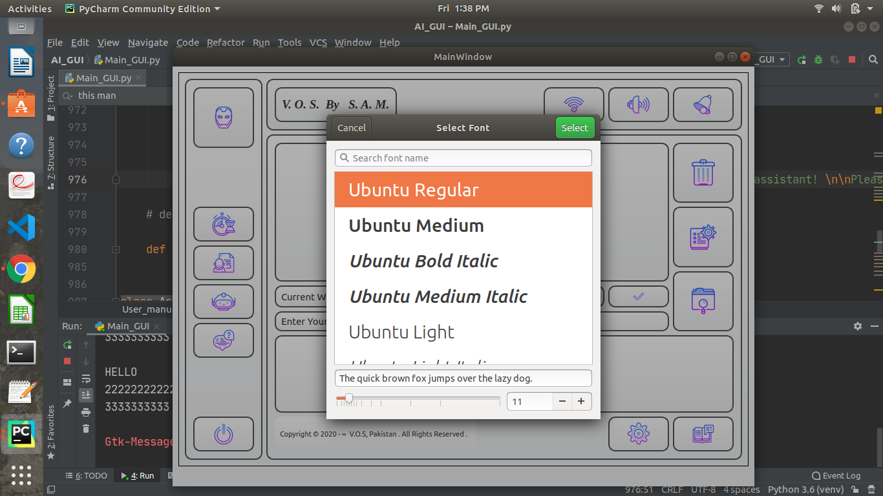

# 

# 

# 

# Execution of Some Commands

# Playing Music

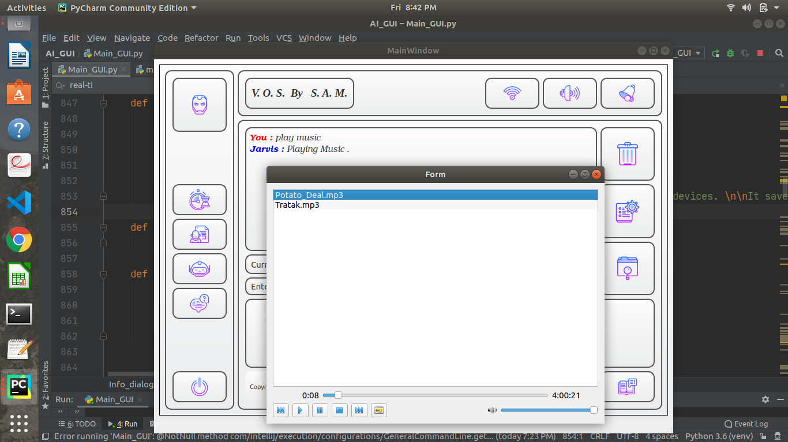

# Playing Videos

# 

# 

# Managing Alarms

# 

# 

# 

# 

# 

# 

# Internet Speed Test

# 

# 

# 

# 

# 

# 

# Getting Full Details of a File

# 

# 

# 

# 

# 

# 

# Displaying Custom Calendar

# 

short dash